# Project—Plan A

Leisure travel has always been one of the most popular forms of entertainment. After market research and IT background research, we clarify that the customer's expectation in independent tourism market is convenient and personalized plan. However, the online tourism Application on the market at present have the problems of serious homogenization and information dispersion. In this case, our mission is that tailor each customer’s travel plan to make travel worry-free and eliminate the gap between consumer expectations and reality. "Plan A” is an information system designed for independent tourists which can be used in mobile phone. It provides users with information about attraction, hotel, restaurant and local entertainment in destination city and users can make order by it. Besides, it can automatically generate travel route for users based on their own choices and result of big data analysis. We believe that Plan A will bring new possibilities to tourism. With Plan A, you never need a plan B.

Project Objective:

(1) Vision: With a Plan A, you never need a plan B.

(2) Mission: Tailor each customer’s travel plan to make travel worry-free and eliminate the gap between consumer expectations and reality.

## 1. Industry: customer segment customer expectation

### 1.1. Customer Segment

According to the tourism population data of various countries published by Statista in 2020i (Table 1), at present, the global tourists are mainly middle- and high-income groups, which accounts for nearly 80% of the tourist population. The proportion of men and women is relatively uniform, and the age of active tourism groups is mainly between 25 and 40 years old.

Table 2. Travelers’ demography in major countries

|  |  |  |  |  |  |
| --- | --- | --- | --- | --- | --- |
| **Main country** | **Proportion** | | | | |
| Male | Female | Medium income | High income | 25-45 years old |
| **US** | 51.2% | 48.8% | 32% | 45% | 47.01% |
| **China** | 47.5% | 52.5% | 34.9% | 39% | 55.7% |
| **Germany** | 48.9% | 51.1% | 32.1% | 42.8% | 57.1% |
| **UK** | 50.1% | 49.9% | 32.7% | 42.4% | 59% |

Moreover, according to the relevant report issued by the International Tourism Organization in 2019 (Figure 1), the proportion of people who take leisure tourism as the main purpose of travel reaches 56%, which shows that leisure tourism is still the main mode of travel for people at present.

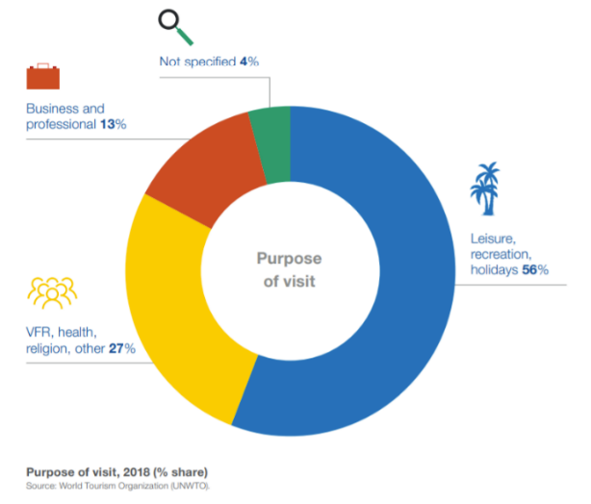

Figure 5. Purpose of Visit (Source: UNWTO)

Therefore, the target users of this product are tourists aged between 25 and 45 who take leisure and entertainment as the main purpose of tourism and prefer personalized tourism services.

### 1.2. Customer Expectation

A report published by Deloitteiii shows that at present, one-stop tourism information platform is still the preferred travel APP for tourists, which shows that such tourists still have a greater demand for integrated tourism information platform. with the improvement of personal income level, people are more in pursuit of personalized travel. Data from Statista shows (Figure 2) that now, in addition to the necessary aviation, hotel booking and car rental software, in the future, the proportion of people using travel planning software will reach 35%, which shows that personalized travel planning has become an obvious travel trend.

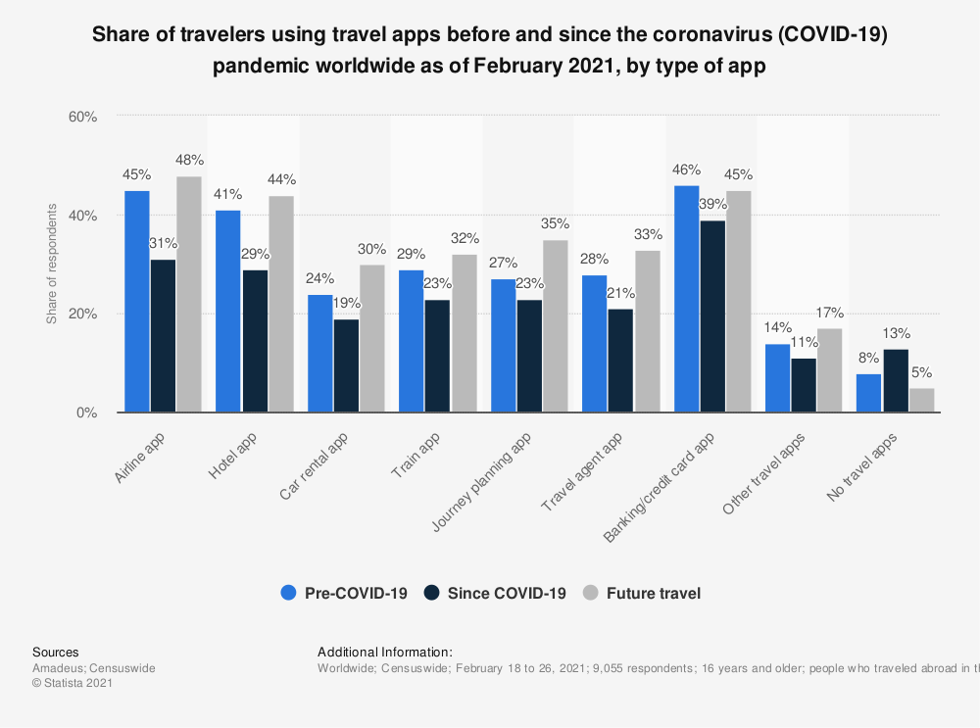

Figure 6. Sharing of Travelers using Travel Apps (Source: Statista)

According to the relevant data provided by Statista, the expectation of using technology to improve personalized tourism experience has reached nearly 55% worldwide, which shows that at present, the public generally expects to use advanced technology to improve personalized tourism experience.

## 2.Product--PlanA

**1)Overview of product:**

Our product is an information system designed for independent tourists. It can be used in mobile phone. It provides users with information about attraction, hotel, restaurant and local entertainment in destination city and users can make order by it. Besides, our application can automatically generate travel route for users based on their own choices and result of big data analysis.

you can see the PlanA product prototype in the following link（our project cloud） ：<https://r4negg.axshare.com>

**2)Technology support for PlanA:**

AI, Big data analysis, VR.

**3)Conceptual design of PlanA:**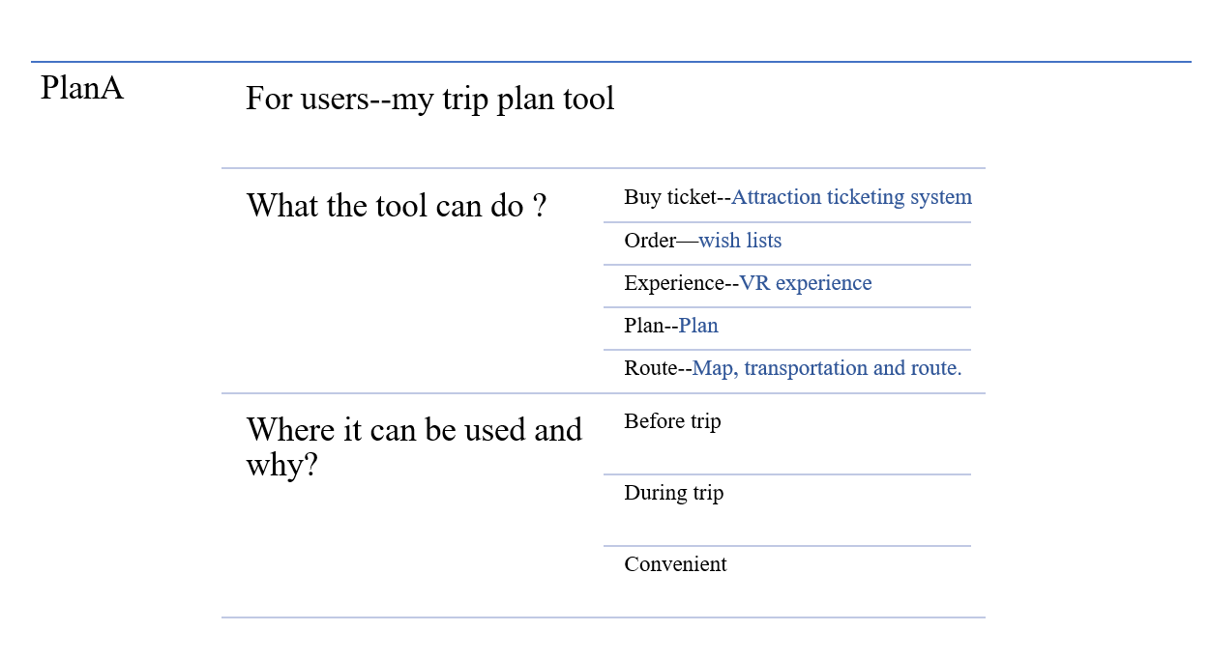

*Figure1: conceptual design of PlanA*

**4)Function requirement of PlanA:**

According to user’s expectation and conceptual design, trip plan and trip route is different functions of PlanA. Meanwhile, it also contains the other normal functions, like making order and buying tickets. Major functions of PlanA and achievement methods are shown in the following list.

Table1: function list of PlanA 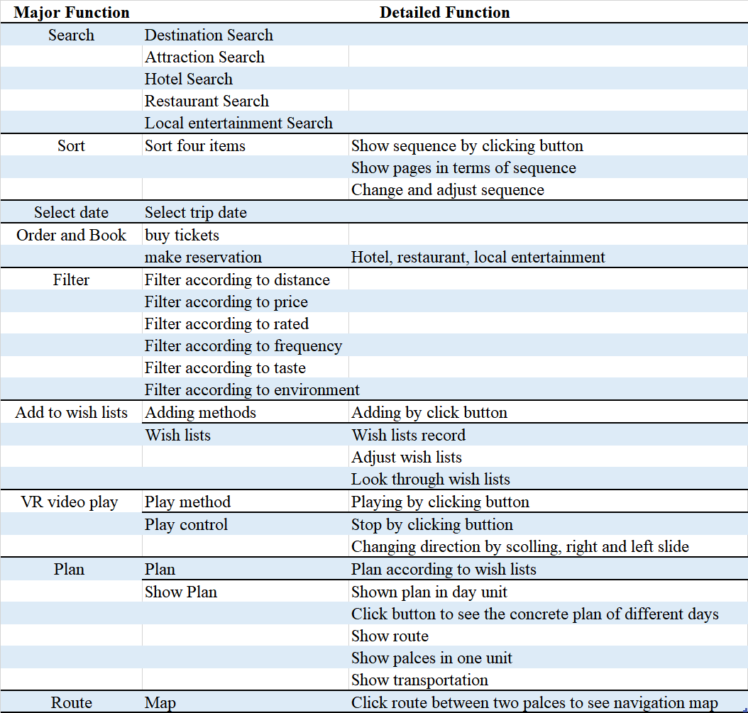

**5)User operating flow and interface design:**

The application is easily operated. Operating Flow of users in the application is followed:

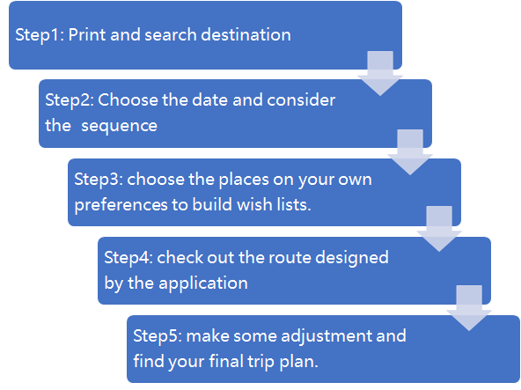

**For step1:**

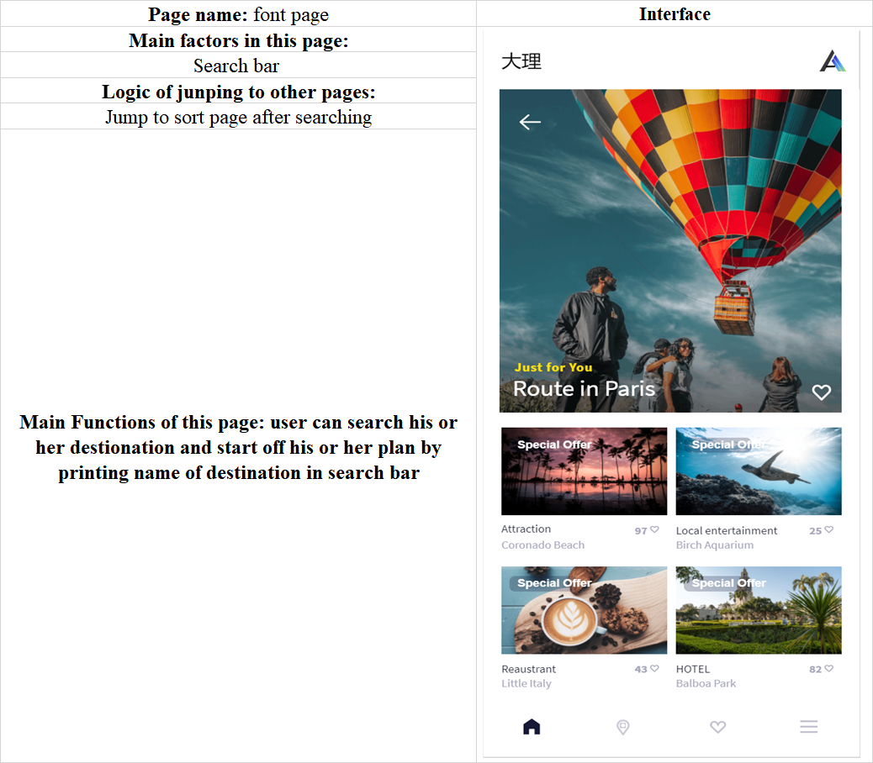

*Figure2: Font page of PlanA*

**For step 2:**

In this stage, users need to consider their own priority and to sort the four items: hotel, attraction, restaurant and local entertainment. The sequence will determine the following stage and Intelligent recommendation will be influenced by the choices in previous stage. For example, if one user’s sequence is attraction, hotel, restaurant and local entertainment. Next stage for the user is to select the attraction, then to select hotel and etc. Meanwhile, when the user selects places in hotel stage, the application will offer intelligent recommendation for user based on attractions choose by users in previous stage. The intelligent recommendation is also based on result of big data analysis generated by AI algorithm. Big data analysis is that according to the tons of accumulating behavioral data, the application can know which places are better for users with the same sequence and similar choices in AI algorithm. For restaurant recommendation, it will blend attractions and hotels selected by users. Likewise, local entertainment recommendation complies with the same principle.

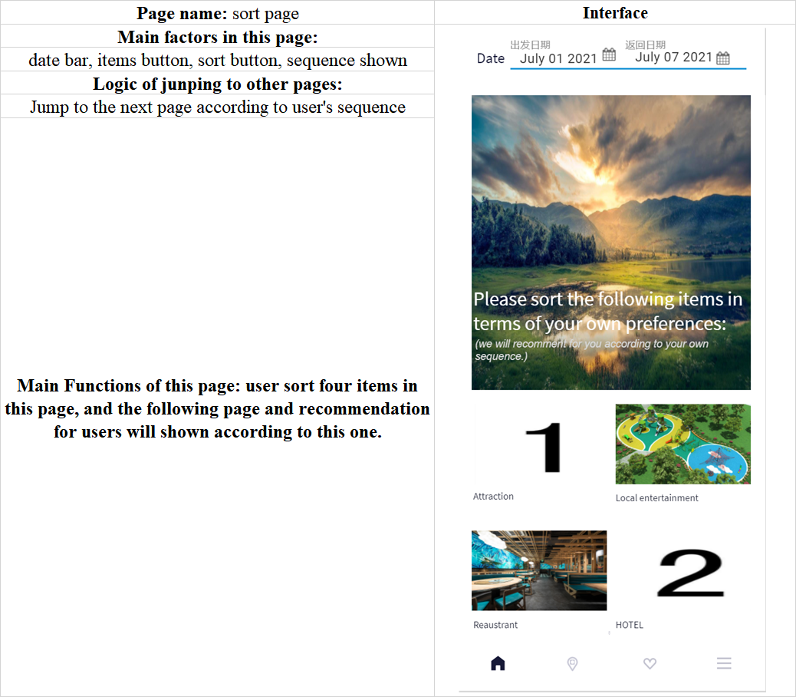

*Figure3: Sort page of PlanA*

**For step 3:**

when making decision, users can know more real situation by VR. The application offers 360-degree video about attraction, hotel, restaurant and local entertainment. In this stage, although smart phone is enough, user can get better view with headset. According to the report from Statista, more people is incline to buy headset in the future. So, with the wide adoption of AR in the future, the application’s VR service will improve.

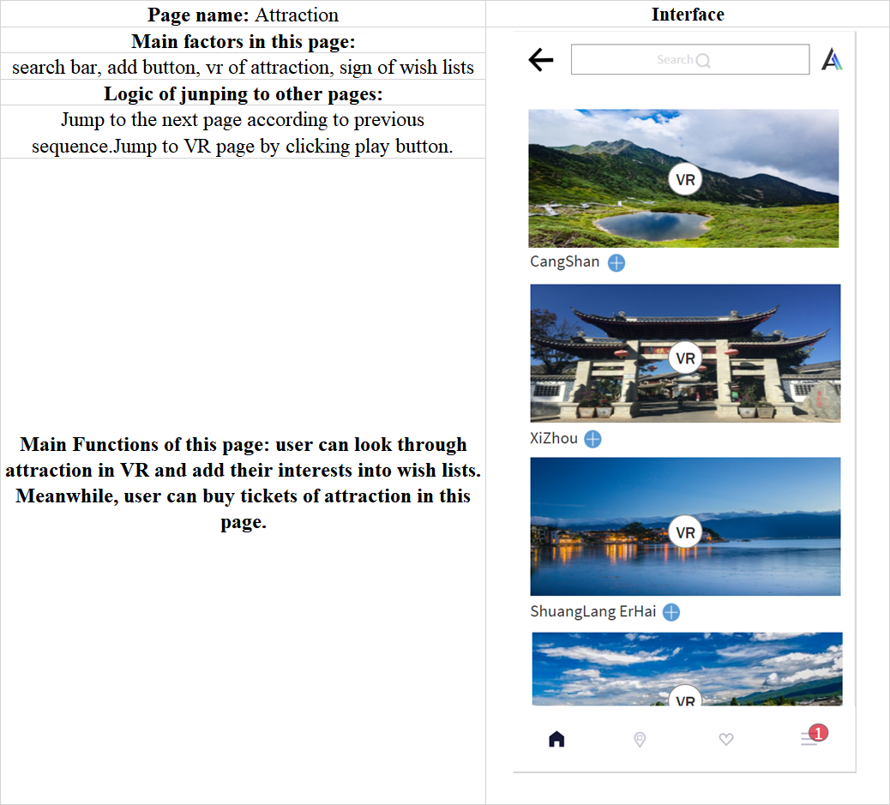

*Figure4: Attraction page of PlanA*

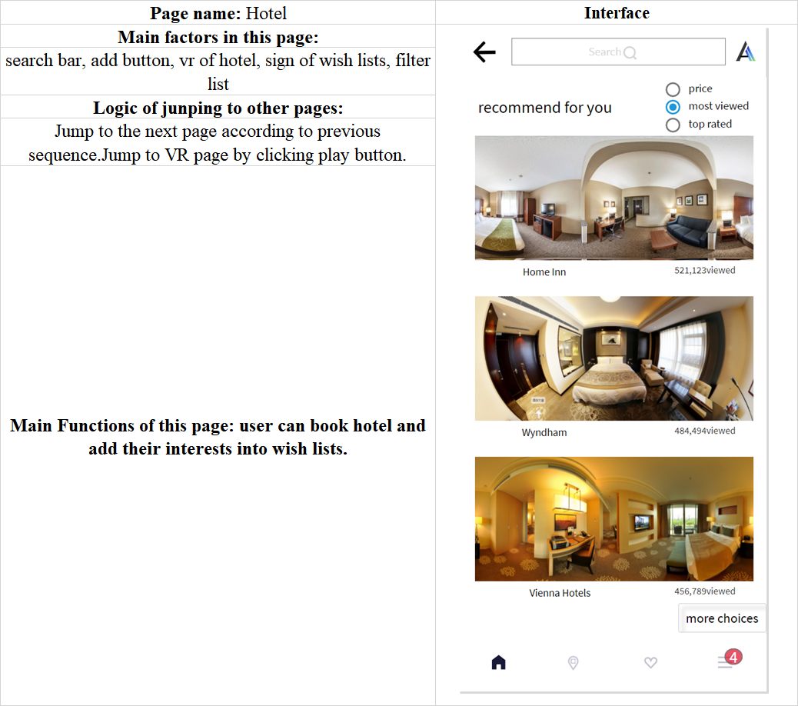

*Figure5: Hotel page of PlanA*

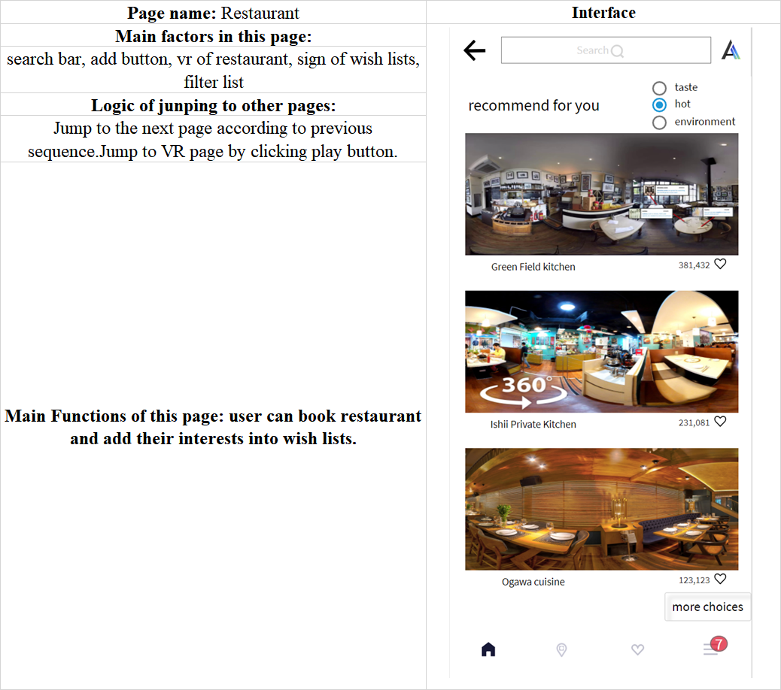

*Figure6: Restaurant page of PlanA*

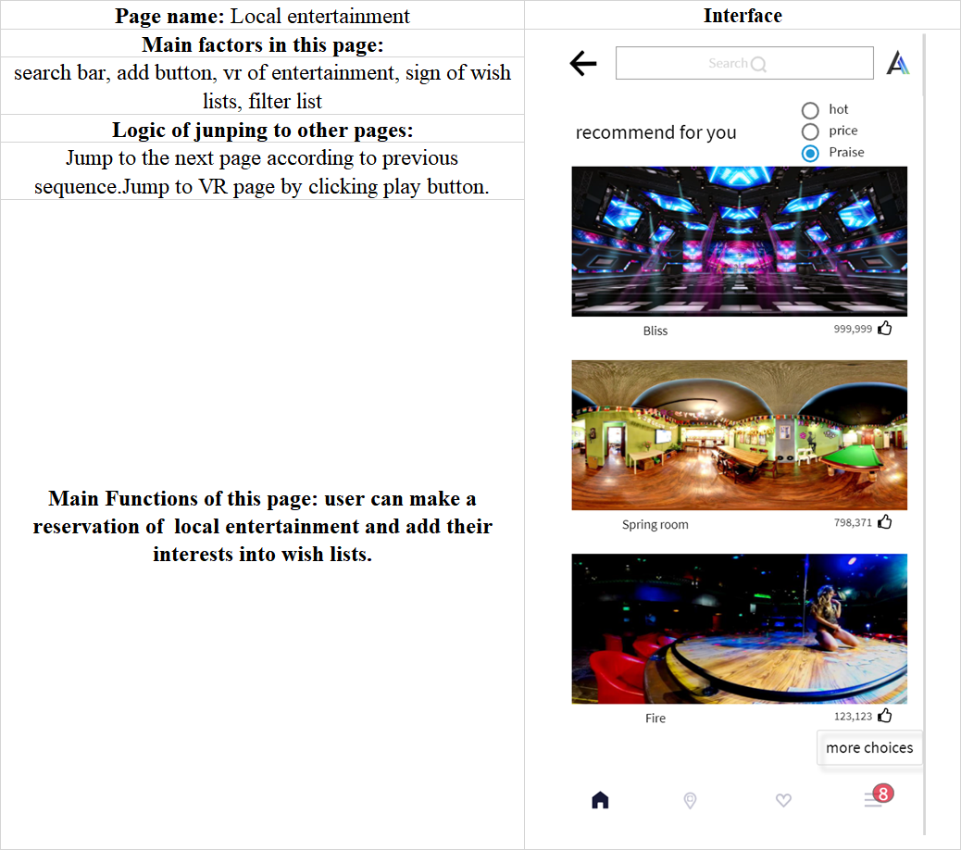

*Figure8: Local entertainment page of PlanA*

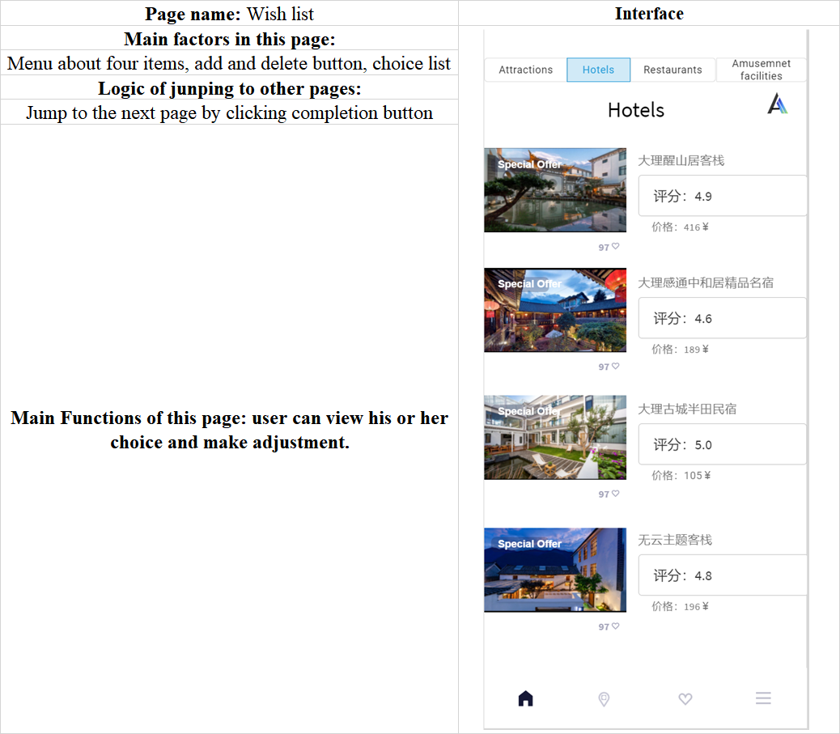

*Figure9: Wish lists page of PlanA*

For step 4:

The application automatically generates trip plan and route for users in AI algorithm. User’s choices will be arranged in day unit. The transportation and route navigation are shown.

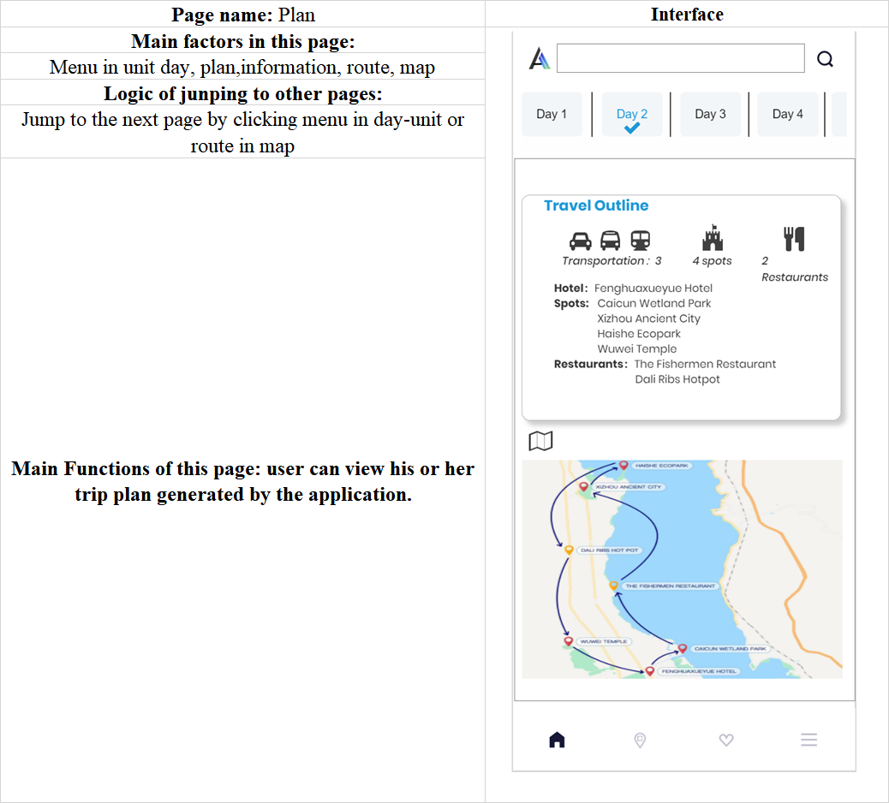

*Figure10: Plan page of PlanA*

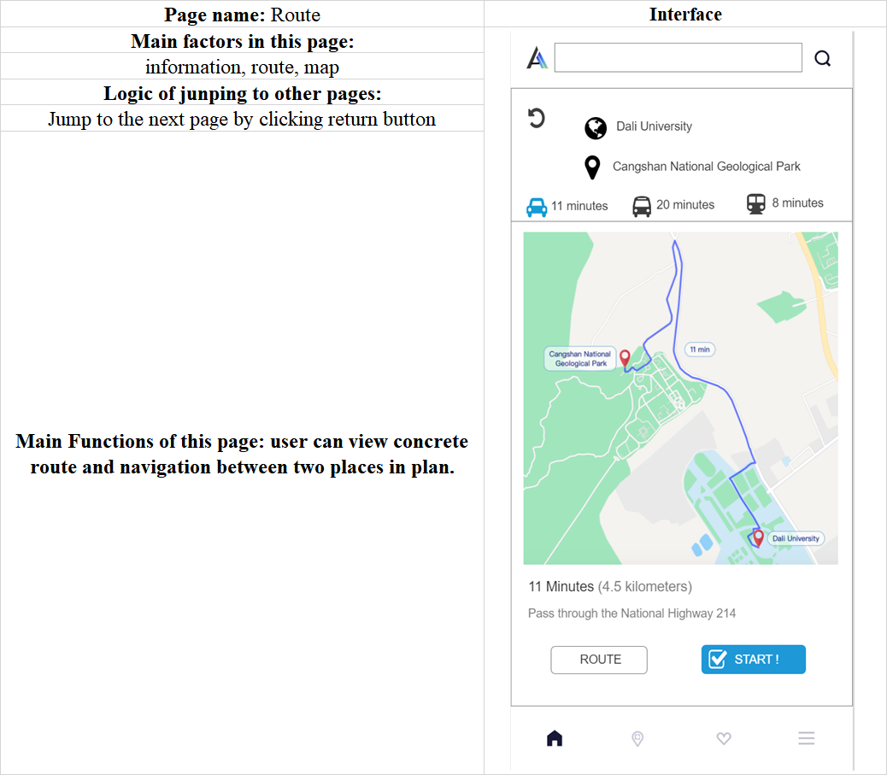

*Figure11: Route page of PlanA*

**6)Product advantages:**

Compared with the current information platform about tourism, the application can design trip plan for users. In this case, there is no need for tourist to collect information in different platform, filter information and make plan on his or her own. It helps to save time and generate customized plan.

## 3. Competition: current major player and their situation

At present, the competitors of Plan A are mainly divided into two categories: one is the other online travel agency like Ctrip, and the other is like the Little Red Book and Mafengwo, which are online platforms providing tourism strategies and information to tourists. Although the Plan A, as a new entrant to the online tourism market, will face greater competitive pressure with these relatively mature enterprises, it also has its own competitive advantages.

(1) OTA

Nowadays, there are many online travel agencies in China. According to the data in Figure 1, it is not difficult to see that the two OTAs with greater influence are the Ctrip and Qunar. Therefore, we will mainly analyze the competitive relationship with these two companies.

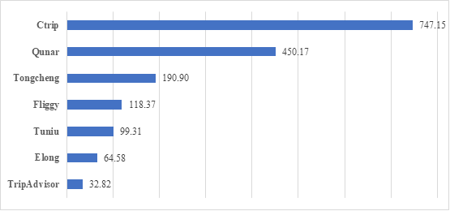

Figure 18. Monthly active number of users of China's OTA in 2020 (million)

Ctrip is a comprehensive online travel agency and is gradually oriented to platform. As China's largest travel service company integrating hotel, air ticket, attraction reservation, tourism information query and preferential merchant services, Ctrip cooperates directly with hotels and airlines to earn commissions through transactions. The higher the price that customers book, the more commissions they will earn. Therefore, Ctrip's target customers are mainly high consumption people like business travelers. Moreover, high priced goods will relatively bring better user experience, and users will give higher evaluation, which will attract more consumers and form a virtuous circle.

Compared with Ctrip, Qunar has obvious platform characteristics and provides price-comparison search services including hotels, air tickets and other products. Customers can compare the prices of different commodities to determine the most favorable tourism scheme. Qunar is targeted at white-collar workers, college students or other people who like to travel economically. It provides them with a variety of group tours with preferential prices and diverse routes. For people who especially enjoy individual travel, there will provide more vacation route to help them find a variety of ways to travel and play. Therefore, Qunar's profit model is quite different from Ctrip's, because it generates profits mainly through online advertising, advertising bidding and enterprise customer service.

(2) Other Online Platform

In addition to the above OTAs, users will also use some other online platforms, such as Little Red Book and Mafengwo, to help them make decisions when considering travel plans. Take the Little Red Book as an example, when planning for their trips, users can search the tourist attractions they are interested in on the home page, and then, they can see many notes published by other users. By reading the contents and pictures of the notes, they can find out what places they want to go during their travel and record those places by likes and collection. After that, the Little Red Book will also recommend relevant content according to the user's search records and preferences, so as to further expand the user's selection range.

The competitive advantages of Plan A will be more obvious than such platforms. Firstly, the Little Red Book and other tourism information platforms cannot realize the booking function of hotel or attraction tickets. Users can only find the hotel or scenic spot they want to go through search first, and then use other OTA platforms for booking. The steps are relatively complex and time-wasting. Secondly, the notes or pictures in the Little Red Book may be far from the real situation, because many publishers may process their pictures through PS and other software to make the photos more beautiful and attractive, which may mislead other users. However, the VR technology used by Plan A can objectively and truly show the appearance of hotels, scenic spots and restaurants, make users more immersive and find the place they really want to go.

## 4. Our company: revenue sources, technology and collaboration, marketing strategy

### 4.1. Income Source

Table 4. Income Source

|  |  |
| --- | --- |
| **Source of income** | **Content** |
| Hotels, Attractions, restaurants，local entertainments | Transaction commission fee |
| Advertising Income（Bidding ranking and advertising space promotion） |
| Normal Users/tourists | VIP account service |

The revenue of this product mainly comes from 3 parts：

Firstly, hotels, restaurants and various local self-employed households can publish information about their respective businesses by registering this platform, and this platform will also provide users with channels such as online booking, ticket booking, etc. After the online transaction is successful, the platform will charge for the transaction commission fee from the relevant merchants.

Secondly, the platform provides advertising services for all merchants. Merchants can improve their exposure and popularity through a series of ways such as bidding ranking and renting advertising space for publicity. The platform will charge a certain amount of advertising fees according to the advertising cycle and the presentation position of the advertising space.

Thirdly, we will charge for VIP account Service. As a VIP member of this product, customers will get more discounts such as hotel booking, restaurant ordering, scenic spot ticket ordering, etc. During the journey, this service will provide users with a private online travel steward, who is responsible for helping tourists solve various practical problems during the journey, such as route change optimization, hotel and restaurant booking services, etc.

### 4.2. Collaboration

There are two main types of our partners: one is hotels, tourists, scenic spots and other businesses that provide information. These partners are not only our customers, but also the main providers of platform information. The other is technology companies that provide VR and navigation technology, such as Google. By connecting their VR technology (Google Earth) and maps (Google Map), the platform can better serve users.

### 4.3. Marketing Strategy

The marketing channels of this product are mainly divided into two categories, one is offline marketing, the other is online marketing, in which online marketing is the main way of product promotion.

(1) Online Marketing

As the most important marketing channel for this product. The main purpose of our online marketing is to promote our brand and services to improve our visibility.

Create hot topics in social media. By putting relevant advertisements in some popular social media like Tok-tok, Twitter, Weibo, and Instagram, we can effectively promote our App. At the same time, we can cooperate with Internet celebrities to create travel topics like # My Plan A, using their influence to attract all kinds of users in social media to actively discuss about this, so as to achieve the purpose of brand promotion.

Put advertisements on video websites and APPs. By launching promotional videos on YouTube, Netflix and other well-known video websites and Apps, we can further effectively promote our products and improve our visibility.

Download registration/ Share rewards. In order to further motivate users to download App, we can carry out registration reward activities to download and use our App. For example, people who download and register as users now can enjoy free activities, hotel reservations, restaurant reservations, scenic spot ticket ordering discounts and so on. In addition, existing users can also become the online promotion media of APP. Through the reward of forwarding and sharing, we can use existing users to carry out effective product promotion. For example, after users forward the App to their friends in Facebook and WeChat, they can get a coupon provided by the App to use when booking or purchasing tickets for hotels, restaurants and scenic spots.

(2) Offline Marketing

Although offline marketing channel are not our main marketing channels, it can also help us expand the popularity of our products. By cooperating with hotels, scenic spots and restaurants, we can publicize App by issuing leaflets. For example, when tourists buy tickets, the staff of the scenic spot can distribute our leaflets to the customers concerned, so as to further improve our publicity.